Exercise 1 (Network inspect)

* <https://developer.mozilla.org/en-US/>
* 34.111.97.67:443
* 26 Requests
* JSON – JS – CSS – HTML – PNG – SVG
* JS cashes File – 600 kB
* 8 ms for the file

Exercise 2 (Simple Node Ser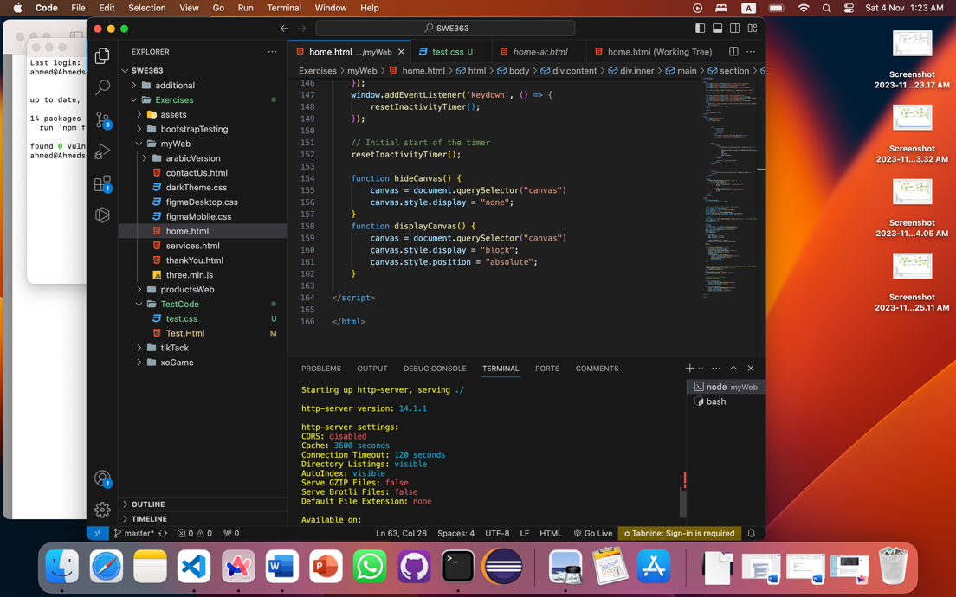ver)

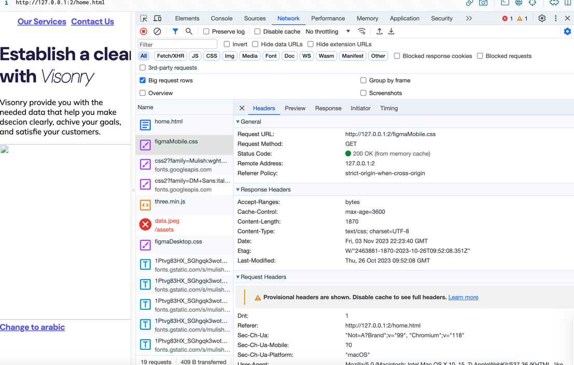

Exercise 3 (Domain Name)

**visionry.net**

<https://ae.godaddy.com/domainsearch/find?domainToCheck=visionry>